MAJOR WILL “D-RAIL” ANDREOTTA
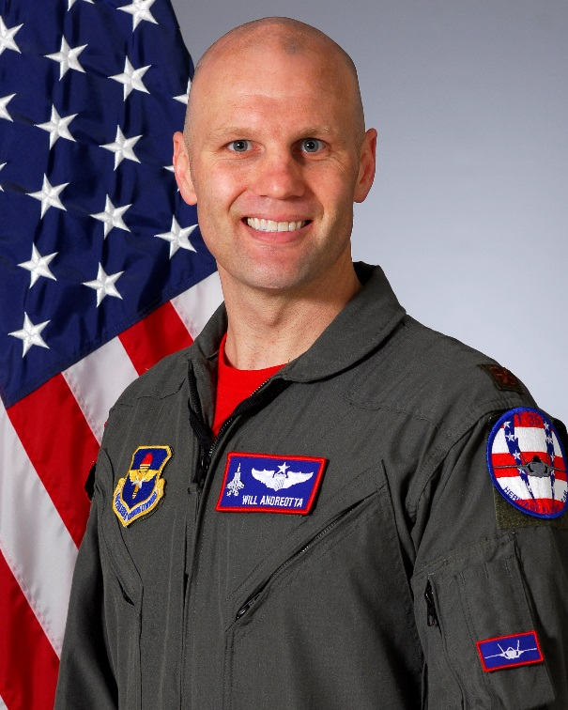
Major Will Andreotta is the United States Air Force’s F-35A Lightning II Heritage Flight Team Commander and Pilot, 56th Fighter Wing, Luke Air Force Base, Arizona. As the F-35A Heritage Flight Commander, he is responsible for representing Air Education and Training Command, Air Combat Command, United States Air Force, Department of Defense, and the United States of America at 16 air shows annually. He leads the sixteen-member F-35A Heritage Flight Team, overseas maintenance actions performed on the Lockheed Martin-produced F-35, and showcases the Air Force’s premier fifth-generation aircraft to millions of spectators each year.

Maj Andreotta earned his commission from ROTC at Arizona State University, where he graduated in 2004 with a Bachelor of Science in criminal justice. He earned his wings from
undergraduate pilot training at Laughlin AFB, Texas, in 2005. After completion of his initial F-16 training at Luke AFB, he was assigned to the 35th Fighter Squadron at Kunsan AB, Republic of Korea as an F-16C pilot, serving as Electronic Combat Pilot and subsequently upgraded to F-16 flight lead. He then was assigned to the 510th FS at Aviano AB, Italy as an F-16CM flight lead where he upgraded to instructor pilot and served as the Assistant Chief of Wing Weapons. Maj Andreotta returned to Luke AFB in 2010 as an F-16 FTU instructor pilot in the 310th FS, serving in many jobs that culminated into his transition to F-16 Flight Examiner for the 56th Operations Group Standardization and Evaluations Flight. He was one of five Luke AFB pilots selected to transition over to the F-35 platform in 2013, and completed the F-35A Instructor Pilot Upgrade at Eglin AFB in April 2014.

Maj Andreotta is a seasoned fighter pilot with more than 2,100 flying hours, including 275 combat hours earned during Operation Enduring Freedom.

EDUCATION
2004 Bachelor of Science in criminal justice, Arizona State University
2010 Squadron Officer School, Maxwell AFB, Alabama
2012 Masters of Aeronautical Sciences, Embry Riddle Aeronautical University
2013 Air Command and Staff College by Correspondence

ASSIGNMENTS
1. May 2004 – July 2005, Student, Joint Specialized Undergraduate Pilot Training, 47th FTW Laughlin AFB, Texas
2. February 2006 – November 2006, Student, F-16C Basic Course, 309th FS Luke AFB, Arizona
3. November 2006 – May 2008, Scheduling Officer/Electronic Combat Pilot, F-16C Flight Lead, 35th FS Kunsan AB, Korea
4. May 2008 – October 2010, Assistant Chief of Wing Weapons, F-16CM Instructor Pilot, 510th FS Aviano AB, Italy
5. October 2010 – February 2014, Flight Commander/Examiner 56th OG Standardization and Evaluations, F-16CM Evaluator, Luke AFB, Arizona
6. February 2014 – April 2014, Student, F-35A Transition Course, 58th FS Eglin AFB, Florida
7. April 2014 – October 2014, Standardization and Evaluation Pilot, F-35A Instructor Pilot, 61st FS Luke AFB, Arizona
8. October 2014 – November 2015, Assistant Director of Operations, F-35A Instructor Pilot, 56th TRS Luke AFB, Arizona
9. November 2015 – Present, F-35 Heritage Flight Team Commander, F-35A Instructor Pilot, 56th FW Luke AFB, Arizona

FLIGHT INFORMATION
Rating: Senior Pilot
Flight hours: more than 2,100
Aircraft flown: (From most recent to least recent platforms) F-35, F-16C/D, AT-38, T-38, T-6

MAJOR AWARDS AND DECORATIONS
AF Meritorious Service Medal
Air Medal with 2 oak leaf clusters
AF Aerial Achievement Medal
AF Commendation Medal
AF Achievement Medal
AF Outstanding Unit Award with 5 oak leaf clusters
Combat Readiness Medal with 1 oak leaf cluster
National Defense Service Medal
Global War on Terrorism Service Medal
Nuclear Deterrence Operations Service Medal
Air Force Expeditionary Service Ribbon with Gold Border
AF Longevity Service with 1 oak leaf cluster
AF Training Ribbon
NATO Medal

EFFECTIVE DATES OF PROMOTION
Second Lieutenant June 02, 2004
First Lieutenant June 02, 2006
Captain June 02, 2008
Major May 01, 2014

(Current as of Janauary 2017)

