STAFF SERGEANT ALEXANDER BOWMAN
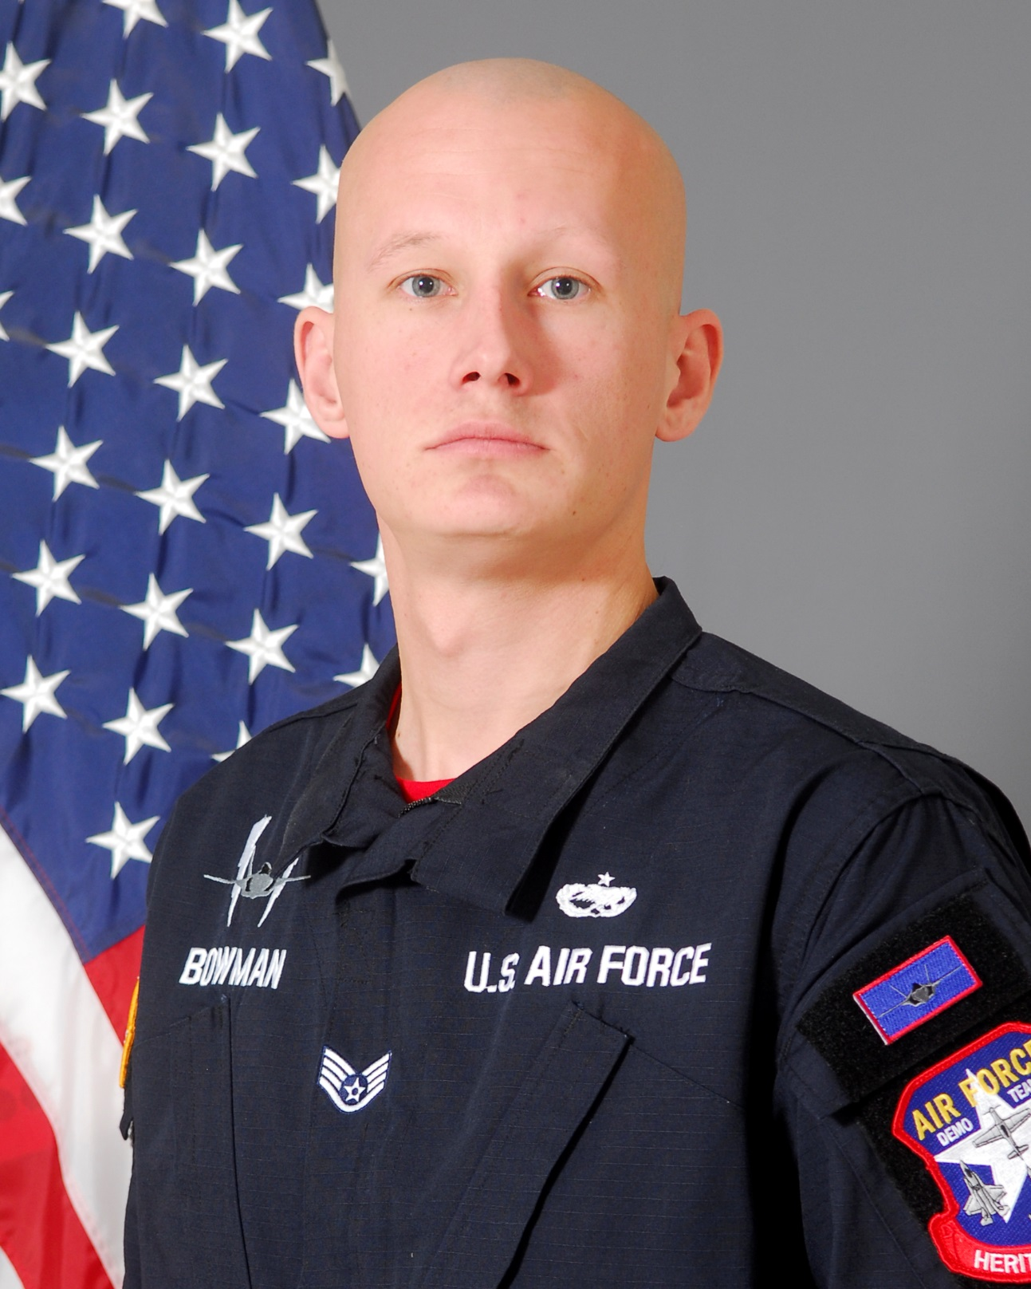
SSgt Alexander Bowman is a member in the United States Air Force’s F-35A Lightning II Heritage Flight Team, 56th Fighter Wing, Luke Air Force Base, Arizona. As an F-35A Heritage Flight team member, he is responsible for representing Air Education and Training Command, Air Combat Command, United States Air Force, Department of Defense, and the United States of America at 16 air shows annually. He is one of sixteen enlisted members of the F-35A Heritage Flight Team and performs maintenance actions on the Lockheed Martin-produced F-35. By doing so, SSgt Bowman ensures Heritage Flight pilots are equipped with a safe and effective F-35A Lightning II to execute their mission of showcasing the Air Force’s premier fifth-generation aircraft for millions of spectators each year.

SSgt Bowman was born in Indianapolis, IN. He graduated from Ramona High School, Riverside, California in 2007. He left for Basic Military Training from Fayetteville, North Carolina December 2009. He attended Technical Training School in Wichita Falls, Texas, for Aerospace Ground Equipment. After graduating from his technical school, he was assigned to his first duty station at Minot AFB, ND as an Aerospace Ground Equipment Apprentice.

EDUCATION
2010 Aerospace Ground Equipment Technical Training School, Sheppard AFB, Texas
2013 Airman Leadership School, Aviano AB, Italy.

ASSIGNMENTS
2010-2011, 5th Maintenance Sq, Aerospace Ground Equipment Apprentice, Minot AFB, ND
2011-2014, 31st Maintenance Sq, Aerospace Ground Equipment Journeyman, Aviano AB, Italy
2014-Present, 56th Equipment Maintenance Sq, Aerospace Ground Equipment Craftsman, Luke AFB, AZ

MAJOR AWARDS AND DECORATIONS
Air Force Achievement Medal with one bronze oak leaf cluster
Air Force Outstanding Unit Award with one bronze oak leaf cluster
National Defense Service Medal
Global War on Terrorism Service Medal
Nuclear Deterrence Operations Service Medal

EFFECTIVE DATES OF PROMOTION
Airman Basic 01 Dec 209
Airman 1st Class 29 Jan 2010
Senior Airman 29 May 2012
Staff Sergeant 1 June 2014

(Current as of December 21, 2016)

