STAFF SERGEANT MARTIN CAREY
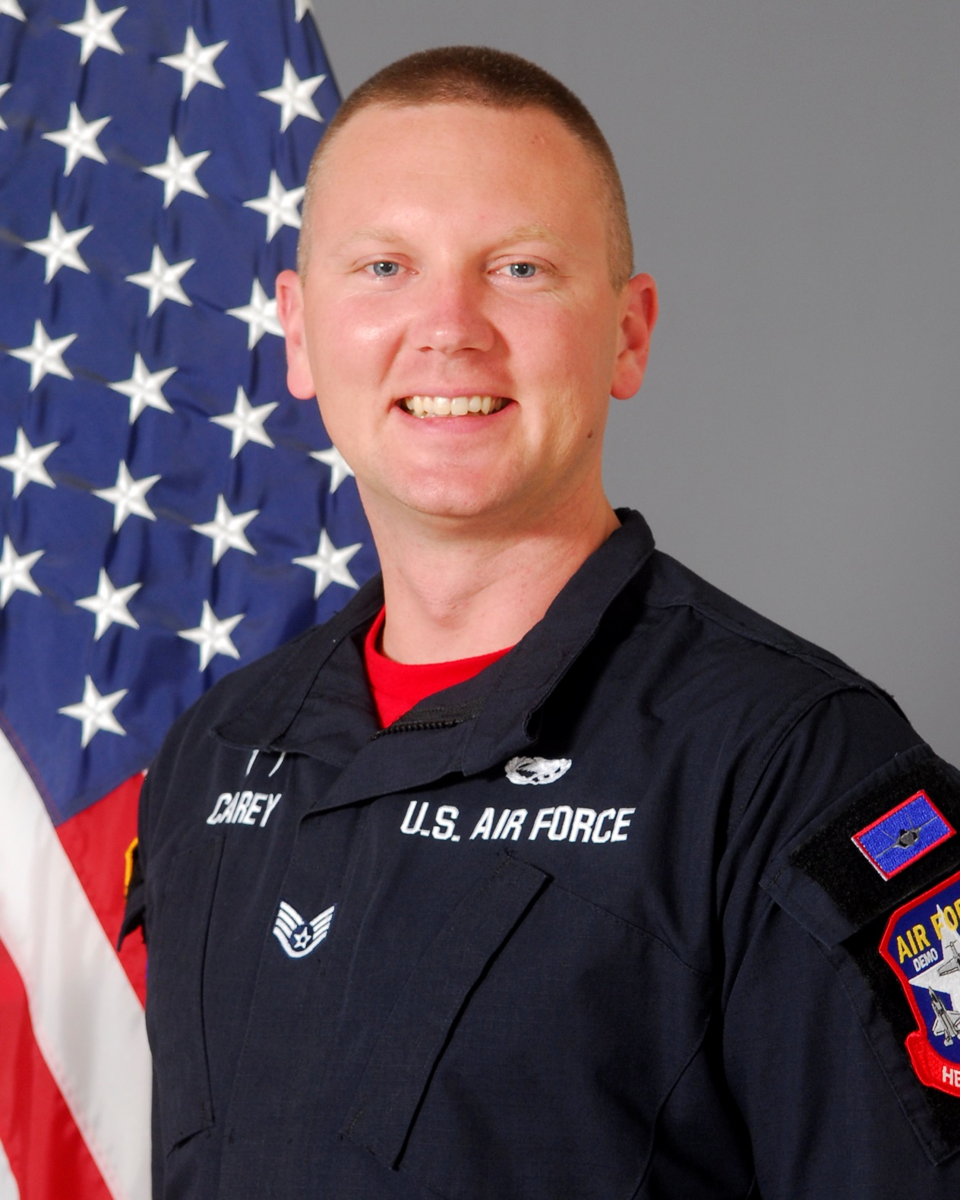
SSgt Martin Carey is a member in the United States Air Force’s F-35A Lightning II Heritage Flight Team, 56th Fighter Wing, Luke Air Force Base, Arizona. As an F-35A Heritage Flight team member, he is responsible for representing Air Education and Training Command, Air Combat Command, United States Air Force, Department of Defense, and the United States of America at 16 air shows annually. He is one of sixteen enlisted members of the F-35A Heritage Flight Team and performs maintenance actions on the Lockheed Martin-produced F-35. By doing so, SSgt Carey ensures Heritage Flight pilots are equipped with a safe and effective F-35A Lightning II to execute their mission of showcasing the Air Force’s premier fifth-generation aircraft for millions of spectators each year.

SSgt Carey was born in Maryville, TN. He graduated from Sequoyah High School, Madisonville, Tennessee in 2005. He left for Basic Military Training in Knoxville, Tennessee July 2011. He attended Technical Training School in Wichita Falls, Texas, for A-10 Tactical Aircraft Maintenance. After graduating from his technical school, he was assigned to his first duty station at Moody AFB, GA as an Assistant Dedicated Crew Chief. He has deployed in support of Operation Enduring Freedom.

EDUCATION
2011 A-10 Tactical Aircraft Maintenance Technical Training School, Sheppard AFB, Texas
2015 Airman Leadership School, Moody AFB, GA.

ASSIGNMENTS
2012-2013, A-10 Assistant Dedicated Crew Chief, 74th Aircraft Maintenance Unit, Moody AFB, GA
2013-2015, A-10 Dedicated Crew Chief, 74th Aircraft Maintenance Unit, Moody AFB, GA
2015-2016, F-35 Assistant Dedicated Crew Chief, 61st Aircraft Maintenance Unit, Luke AFB, Arizona
2016-Present, F-35 Dedicated Crew Chief, 56th Aircraft Maintenance Squadron, Luke AFB, Arizona

MAJOR AWARDS AND DECORATIONS
Air Force Achievement Medal
Meritorious Unit Award with oak leave cluster
Air Force Outstanding Unit Award with oak leave cluster
Global War on Terrorism Service Medal
Air Force Expeditionary Service Ribbon with Gold Border

EFFECTIVE DATES OF PROMOTION
Airman Basic 26 July 2011
Airman 1st Class 23 Sept 2011
Senior Airman 23 Jan 2014
Staff Sergeant 1 Dec 2016

(Current as of December 1, 2016)

