TECHNICAL SERGEANT ALEKSANDR A. DOLGIKH JR
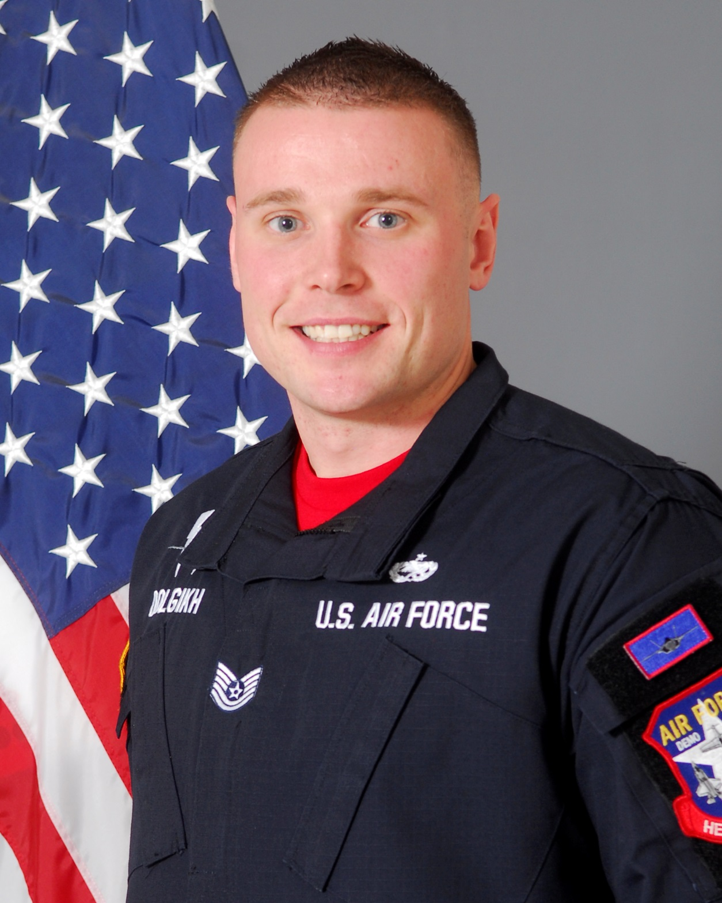
TSgt Aleksandr Dolgikh is a member in the United States Air Force’s F-35A Lightning II Heritage Flight Team, 56th Fighter Wing, Luke Air Force Base, Arizona. As an F-35A Heritage Flight team member, he is responsible for representing Air Education and Training Command, Air Combat Command, United States Air Force, Department of Defense, and the United States of America at 16 air shows annually. He is one of sixteen enlisted members of the F-35A Heritage Flight Team and performs maintenance actions on the Lockheed Martin-produced F-35. By doing so, TSgt Dolgikh ensures Heritage Flight pilots are equipped with a safe and effective F-35A Lightning II to execute their mission of showcasing the Air Force’s premier fifth-generation aircraft for millions of spectators each year.

TSgt Dolgikh was born in Omsk, Russia. He graduated from West Bloomfield High School, West Bloomfield, Michigan in 2007. He left for Basic Military Training in Detroit, Michigan December 2007. He attended Technical Training School in Wichita Falls, Texas, for Tactical Aircraft Maintenance. After graduating from his technical school his career included maintaining F16C/D Fighting Falcon at Eielson AFB, Alaska, F-15E Strike Eagle at RAF Lakenheath, United Kingdom, and finally receiving an assignment to Luke AFB to maintain the F-35A Lightning II where he is a Dedicated Crew Chief. He has deployed in support of Operation Enduring Freedom, Operation Odyssey Dawn.

EDUCATION
2007 West Bloomfield High School, Michigan
2008 F-16 Tactical Aircraft Maintenance Technical Training School, Sheppard AFB, Texas
2011 Airman Leadership School, RAF Lakenheath, UK.
2014 CCAF-Associate Degree in Aircraft Maintenance Technology
2016 Non Commissioned Officer Academy, Luke AFB, Arizona

ASSIGNMENTS
2008-2011, F-16C/D Assistant Dedicated Crew Chief, 354th Aircraft Maintenance Unit, Eielson AFB, Alaska
2011-2014, F-15E Dedicated Crew Chief, 494th Aircraft Maintenance Unit, Lakenheath AB, United Kingdom
2014-2016, F-35A Dedicated Crew Chief, 61st Aircraft Maintenance Unit, Luke AFB, Arizona
2016-Present, F-35 Dedicated Crew Chief, 56th Aircraft Maintenance Squadron, Luke AFB, Arizona

MAJOR AWARDS AND DECORATIONS
Air Force Commendation Medal
Air Force Achievement Medal
Air Force Outstanding Unit Award
Air Force Good Conduct Medal
National Defense Service Medal
Global War on Terrorism Expeditionary Medal
Global War on Terrorism Service Medal
Air Force Expeditionary Service Ribbon with Gold Border
Small Arms Expert Marksmanship Ribbon
ALS Distinguished Graduate Award
Maintenance Professional of the Year NCO Award

EFFECTIVE DATES OF PROMOTION
Airman Basic 18 December 2007
Airman 1st Class 1 February 2008
Senior Airman 1 December 2009
Staff Sergeant 1 February 2011
Technical Sergeant 1 January 2017

(Current as of January 1, 2017)

