**STAFF SERGEANT PATRICK MURPHY**

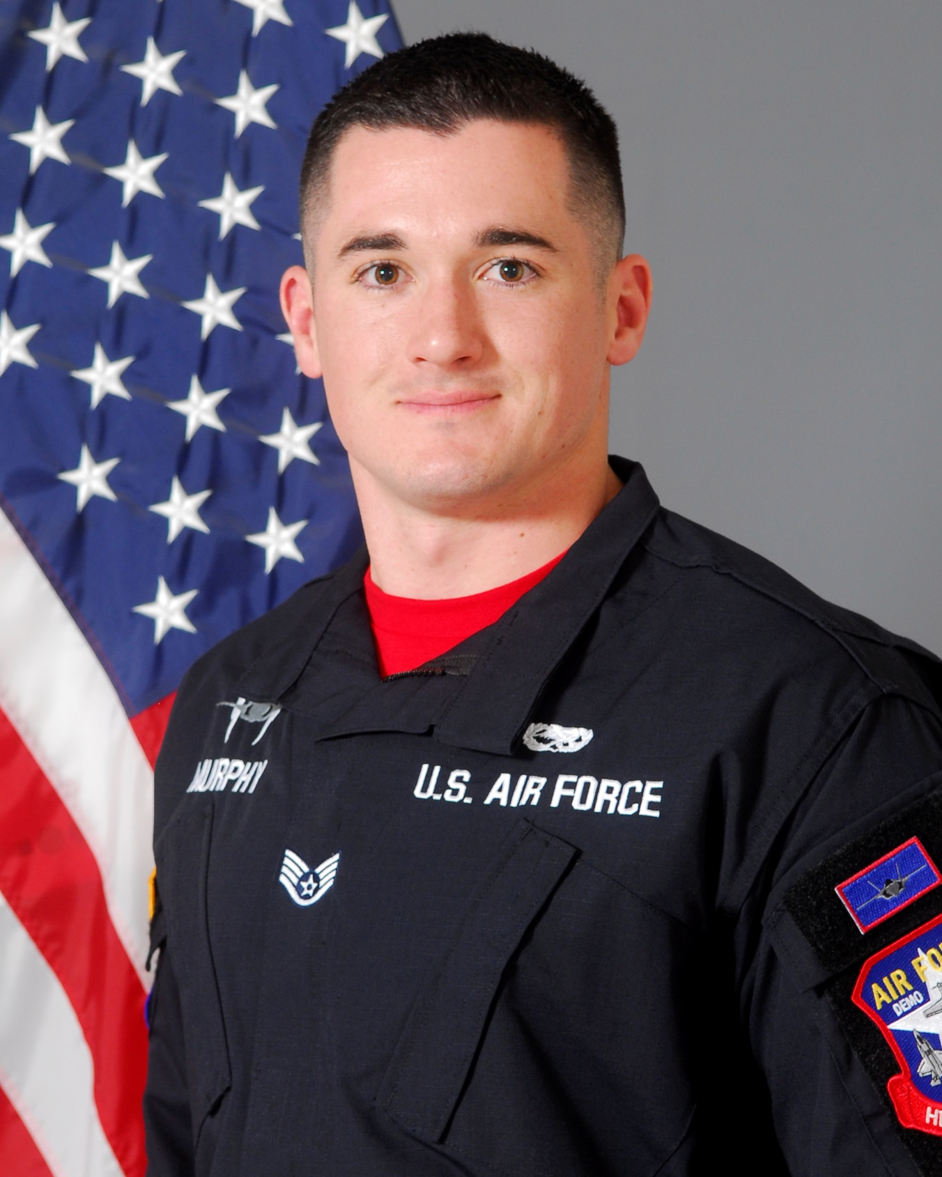

SSgt Patrick Muprhy is a member in the United States Air Force’s F-35A Lightning II Heritage Flight Team, 56th Fighter Wing, Luke Air Force Base, Arizona. As an F-35A Heritage Flight team member, he is responsible for representing Air Education and Training Command, Air Combat Command, United States Air Force, Department of Defense, and the United States of America at 16 air shows annually. He is one of sixteen enlisted members of the F-35A Heritage Flight Team and performs maintenance actions on the Lockheed Martin-produced F-35. By doing so, SSgt Murphy ensures Heritage Flight pilots are equipped with a safe and effective F-35A Lightning II to execute their mission of showcasing the Air Force’s premier fifth-generation aircraft for millions of spectators each year.

SSgt Murphy was born in Grand Junction, CO. He graduated from Cienega High School, Vail, AZ in 2010. He left for Basic Military Training in Phoenix, AZ May 2012. He attended Technical Training School in Wichita Falls, Texas, for F-22 Tactical Aircraft Maintenance. After graduating from his technical school, he was assigned to his first duty station at Tyndall AFB, FL as an F-22 Assistant Dedicated Crew Chief and he is currently an F-35A Assistant Dedicated Crew Chief on the 56th Fighter Wing aircraft. He has been on many TDYs around the United States supporting Tyndall’s and Luke’s Mission of training the world’s greatest F-22,F-35 and F-16 fighter pilots.

**EDUCATION**

2010 Cienega High School Vail, AZ

2012 F-22 Tactical Aircraft Maintenance Technical Training School, Sheppard AFB, Texas

2016 Airman Leadership School, Luke AFB, Arizona

**ASSIGNMENTS**

2012-2014, F-22 Assistant Dedicated Crew Chief, 43rd Aircraft Maintenance Unit, Tyndall AFB, FL

2014-2016, F-35 Assistant Dedicated Crew Chief, 61st Aircraft Maintenance Unit, Luke AFB, Arizona

2016-Present, 56th AMXS - F-35 Heritage Flight Team, Luke AFB, Arizona

**MAJOR AWARDS AND DECORATIONS**

Air Force Achievement Medal

Meritorious Unit Award

Air Force Outstanding Unit Award with oak leave cluster

Global War on Terrorism Service Medal

**EFFECTIVE DATES OF PROMOTION**

Airman Basic 06 MAR 2012

Airman 1st Class 04 MAY 2012

Senior Airman 04 MAR 2014

Staff Sergeant 01 JAN 2017

(Current as of December 1, 2016)